**STRING ASSIGNMENT**

**QUESTION1**

**CODE**

import java.util.Scanner;

class StringQn1

{

public static void main(String arg[])

{

Scanner s = new Scanner(System.in);

String str = s.nextLine();

char c[]=str.toCharArray();

int lc=0;

int count=0;

for(int i=0;i<c.length;i++)

{

boolean x = true;

for(int k=0;k<i;k++){

if(c[i]==(str.charAt(k))){

x = false;

}

}

if(x){

for(int j=0;j<str.length();j++)

{

if(c[i]==str.charAt(j))

count=count+1;

}

System.out.println(c[i]+" "+" "+(count));

count=0;

lc++;

}

}

}

}

OUTPUT

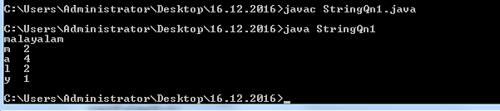

**QUESTION 2**

**CODE**

import java.util.Scanner;

class StringQn1

{

public static void main(String arg[])

{

Scanner s = new Scanner(System.in);

String str1 = s.nextLine();

System.out.println(str1);

StringBuffer sf = new StringBuffer(str);

System.out.println(sf.reverse());

}

}

**OUTPUT**

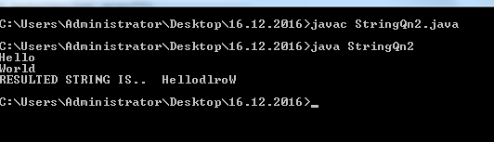

**QUESTION 4**

**CODE**

import java.util.Scanner;

class StringQn3

{

public static void main(String arg[])

{

Scanner s = new Scanner(System.in);

String str = s.nextLine();

char c[]=str.toCharArray();

//System.out.println(str.charAt(2));

char s1 = str.charAt(0);

char t = str.charAt(str.indexOf(" ")+1);

char u = str.charAt(str.lastIndexOf(" ")+1);

//System.out.println(s);

//System.out.println(s1+""+t+""+u);

char ch[] = {s1,t,u};

//System.out.println(ch);

String st = new String(ch);

System.out.println(st.toUpperCase());

char s2 = str.charAt(0);

char t1 = str.charAt(str.lastIndexOf(" ")-1);

int a = str.length();

//System.out.println("LENGTH");

//System.out.println(a-1);

char u1 = str.charAt(a-1);

char ch1[] = {s2,t1,u1};

String st1 = new String(ch1);

StringBuffer sf = new StringBuffer(st1);

sf = sf.reverse();

System.out.println(sf);

}

}

**OUTPUT**

